GROUP PROJECT — MULTI-FACTOR AUTHENTICATION FOR VISUALLY IMPAIRED USERS Individual Design Document 5 / 5

SECURITY ARCHITECTURE & THREAT MODEL
Security Architecture and Threat Model
Cross-cutting security design covering trust boundaries, data protection, and a STRIDE threat model across both the biometric and voice-call factors.
GROUP NAME | [Group Name] | MODULE | Computer Security — Group Project
STUDENT NAME (INITIALS) | [E. Student] | STUDENT ID | [Student ID]
DATE | 15 September 2026 | CONTRIBUTION AREA | Security Architecture & Threat Model

1 SCOPE OF MY CONTRIBUTION
My contribution is the cross-cutting security design: the trust boundaries between the client, the backend, and the telephony provider established in Document 1; the data-protection rules that constrain how Documents 2 and 3 must handle biometric and OTP data; and a structured threat model (STRIDE) identifying the main attacks against the whole system and the mitigation each one relies on.
2 ASSUMPTIONS
E1 All client–server traffic is carried over TLS 1.3; no endpoint accepts plaintext HTTP.
E2 OTP codes are stored server-side only as salted hashes with a short time-to-live, and are never written to logs in plaintext.
E3 Per Document 2, biometric assertions are public-key signatures only; a full server compromise cannot leak biometric templates because none are ever stored there.
E4 SIM-swap and call/voicemail-forwarding attacks against the voice-call factor are acknowledged as a residual risk not fully mitigated in this academic prototype; their impact is reduced because an attacker would still separately need the victim's enrolled biometric device (E3) to complete authentication.
E5 The third-party telephony provider (e.g. Twilio) is treated as a trusted processor under a standard data-processing agreement — a simplifying assumption appropriate for an academic system, not a production compliance judgement.
3 TRUST-BOUNDARY DATA-FLOW DIAGRAM
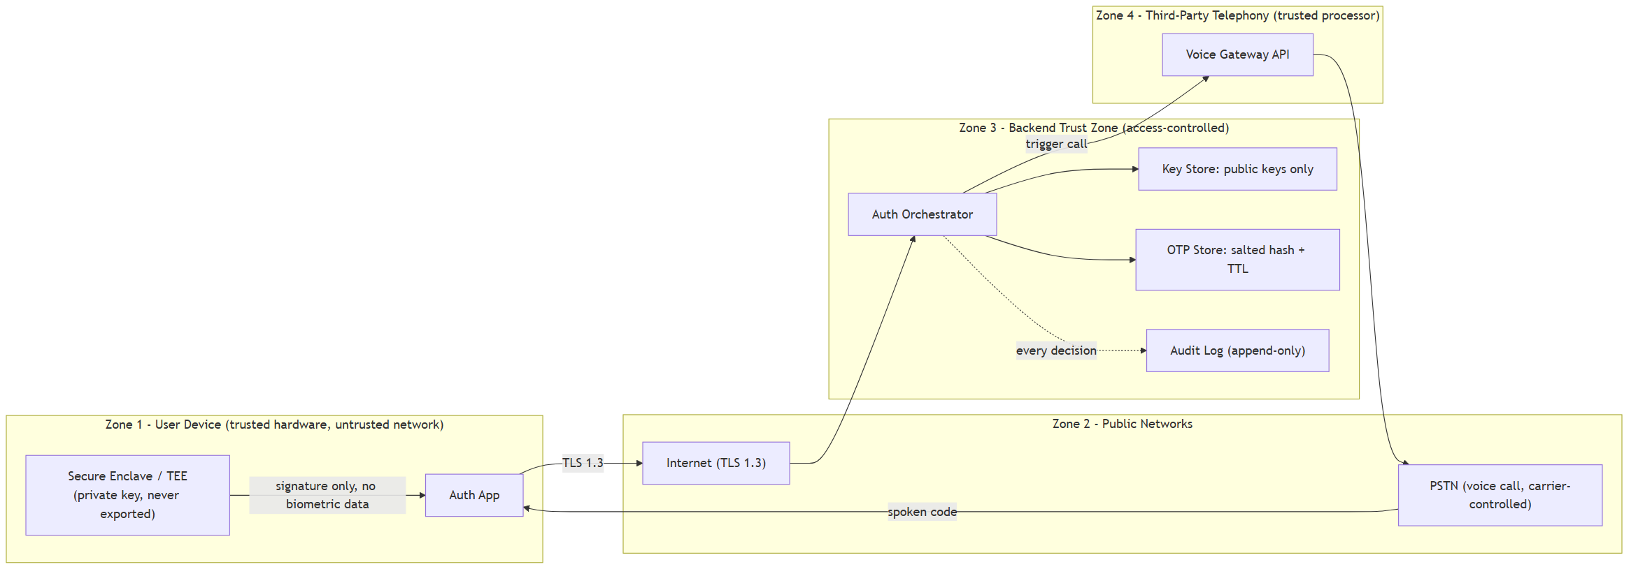
Figure 1. Trust-boundary data-flow diagram. Each subgraph is a trust zone; every arrow crossing a zone boundary is a point evaluated in the STRIDE table below.
4 STRIDE THREAT MODEL
THREAT | SCENARIO | MITIGATION | SEVERITY
Spoofing | Attacker attempts to authenticate as the victim without the victim's device. | Biometric factor requires the enclave-bound private key (Document 2); unforgeable without physical device access. | Low
Tampering | Attacker intercepts and modifies the OTP or challenge in transit. | TLS 1.3 on all client–server traffic (E1); signed challenge-response prevents undetected modification. | Low
Repudiation | User or attacker denies an authentication event occurred. | Append-only audit log records every factor outcome with timestamp (Document 1, FR6). | Low
Information Disclosure | Backend database is breached. | No raw biometric data server-side (E3); OTPs stored only as short-lived salted hashes (E2). | Medium
Denial of Service | Attacker repeatedly triggers voice calls to the victim's phone as harassment, exploiting that only an identifier is needed to start a call. | Rate limiting on call-trigger endpoint, capped retries (Document 3, §5). Disproportionately affects a blind victim who cannot easily screen calls visually, making this a priority mitigation. | High
Elevation of Privilege | A partially-compromised factor grants more access than intended. | Orchestrator enforces that all required factors independently succeed before issuing a session token; authorization checks are separate from authentication result. | Medium
SIM-swap / call forwarding | Attacker redirects the victim's calls to intercept the voice OTP. | Not fully mitigated (E4) — accepted residual risk; impact bounded by the requirement that the biometric factor, bound to the victim's physical device, must also succeed. | High (residual)

5 DESIGN DECISIONS & JUSTIFICATION
DECISION | JUSTIFICATION
Require factors from two structurally different channels (device-bound crypto key over data network; voice over PSTN) rather than two factors on the same channel. | NIST SP 800-63B requires AAL2 to combine two distinct factor categories; using channel-diverse delivery (data network vs. telephone network) means a single compromised network does not expose both factors, exceeding the standard's minimum.
Apply STRIDE as the threat-modelling method. | STRIDE is a widely documented, systematic methodology (Shostack, 2014) well suited to a bounded system with a clear data-flow diagram, making it appropriate for an academic-scope threat model covering all six threat categories without requiring a full production risk-scoring exercise.
Rank the voice-call denial-of-service scenario as the highest-severity item, above generic information disclosure. | Because the target users are visually impaired, an attacker flooding their phone with authentication calls is not just an availability problem but a direct harassment vector this population is less able to screen or block visually — the severity ranking reflects the accessibility context, not just standard CVSS-style impact.
Explicitly accept SIM-swap as a residual, not eliminated risk rather than over-claiming a fix. | Full SIM-swap mitigation (e.g. carrier-level number-porting alerts) is outside the control of an application-layer design and outside this project's scope; stating it honestly as residual, bounded by the second independent factor, is more defensible than an unsubstantiated claim of full mitigation.

6 REFERENCES
National Institute of Standards and Technology (2017) SP 800-63B: Digital Identity Guidelines — Authentication and Lifecycle Management. Gaithersburg, MD: NIST.
OWASP Foundation (2021) Application Security Verification Standard (ASVS) v4.0.
Shostack, A. (2014) Threat Modeling: Designing for Security. Indianapolis: Wiley.
Twilio Inc. Voice API Security Documentation. Available at: twilio.com/docs/voice/security.
Individual Contribution — Submission 1 5 / 5

